COLOUR PALETTE:
Sad Foundation Colours
Slate Gray - #708090
Faded Indigo - #4A607A
Washed Earth Brown - #8B7D7B

Inspiring Colours
Sunlit Yellow - #FFD23F
Golden Amber - #FFB627
Sunrise Peach - #FF9F5A
Vivid Orange - #FF7A3D
Warm White - #FBF1E0

FONTS:
LOOK AGAIN (Berlin Sans FB Demi); LOOK AGAIN (Lemon)

ICONS/ELEMENTS:


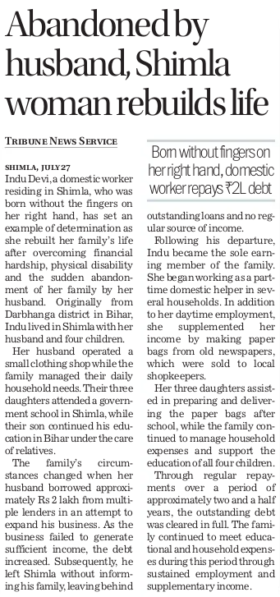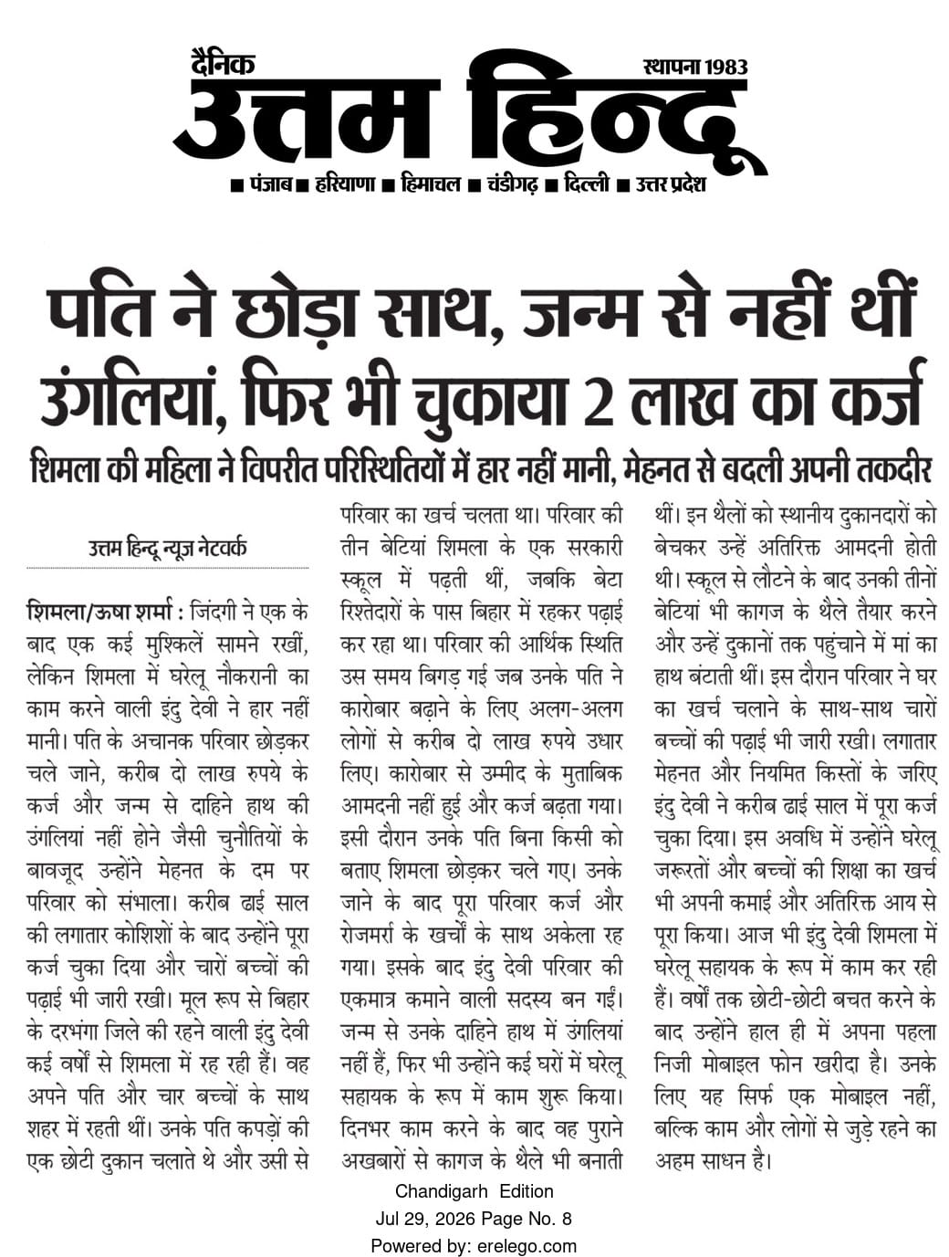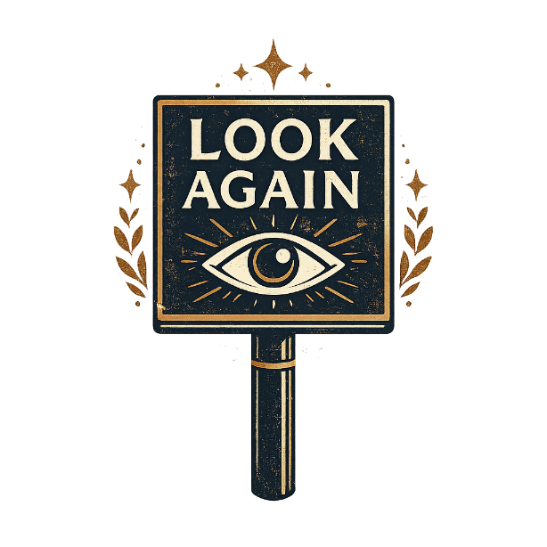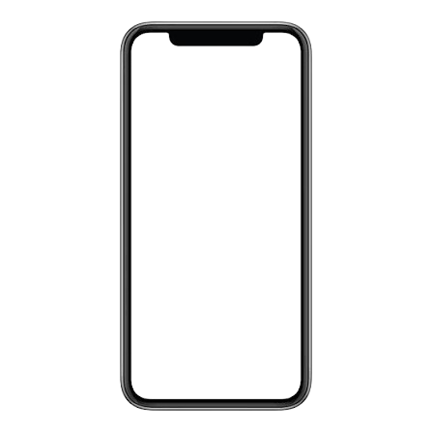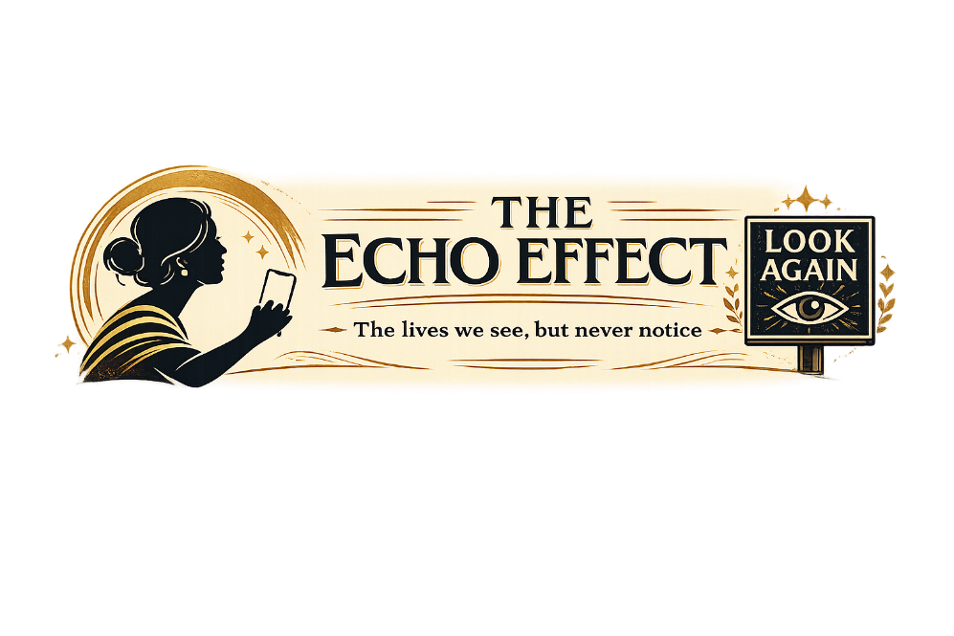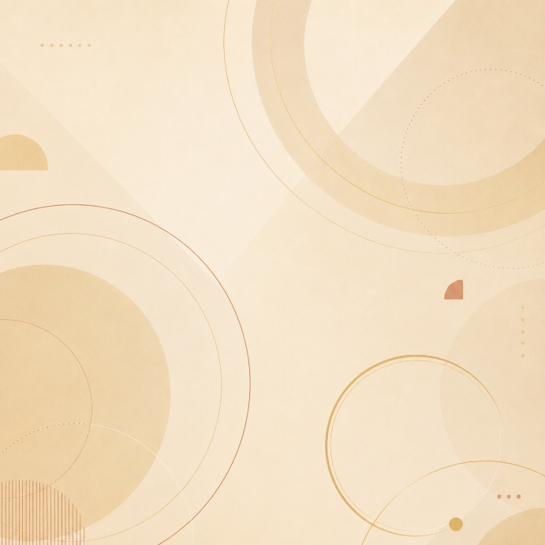

Woman
Bird
Shackles
Colors – Contrasting
Bright Phone Color
Echo Effect Sound Wave
Look Again
Background – Orangish (Gradient)

